**2013-14 Activies**

**Guest Lecture by Dr Sahadevudu Lecturer in History ,GDC**

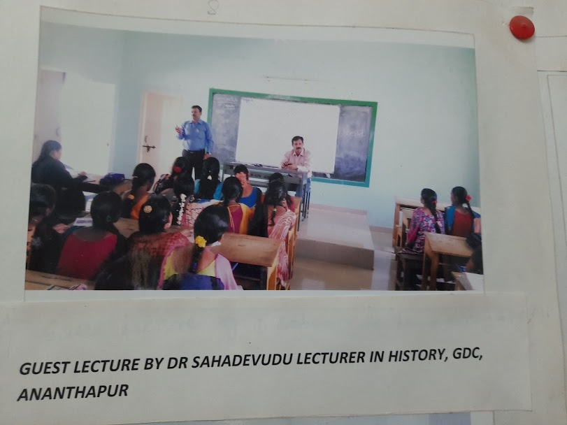

**Class Debates on AIDs Awareness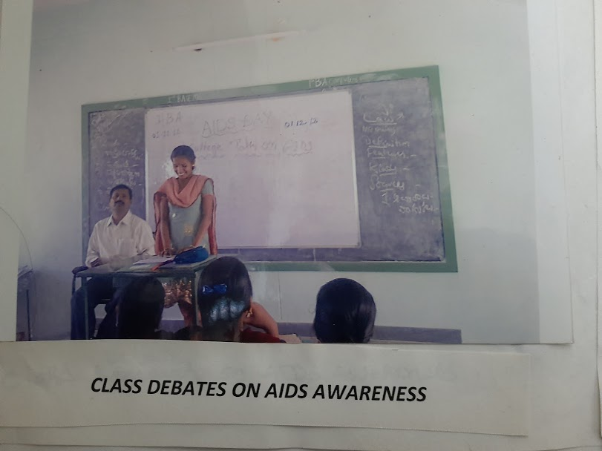Student Seminar I BA K.Gowthami**

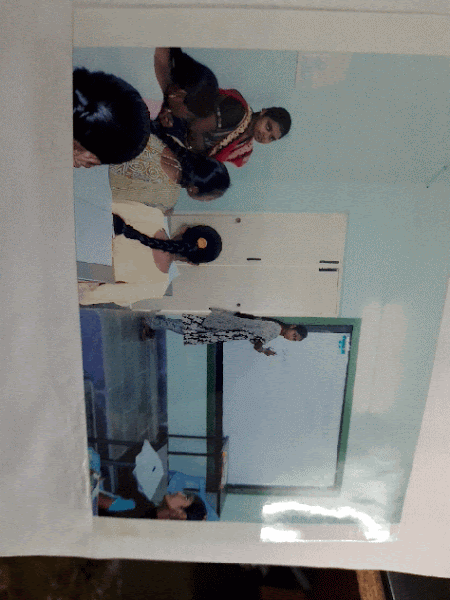

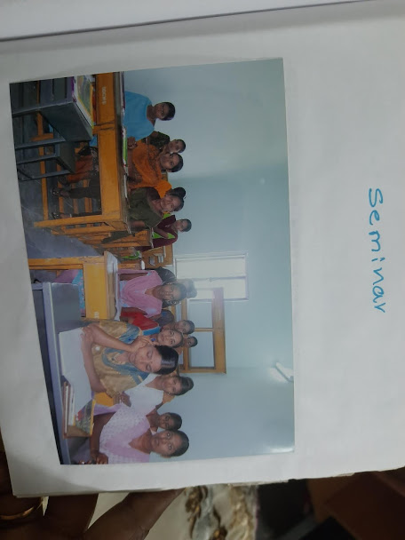

**Field Study**

Dr.K.V.Ramana,Reader in History Described about Archaeological evidence of Indian History

In Archaeology Museum

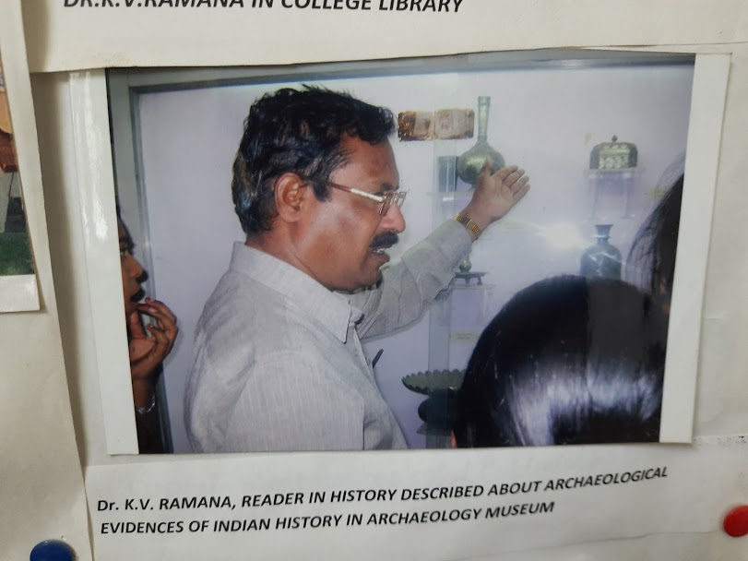

**2015-16 Activities**

**Field Trip Belum Caves**

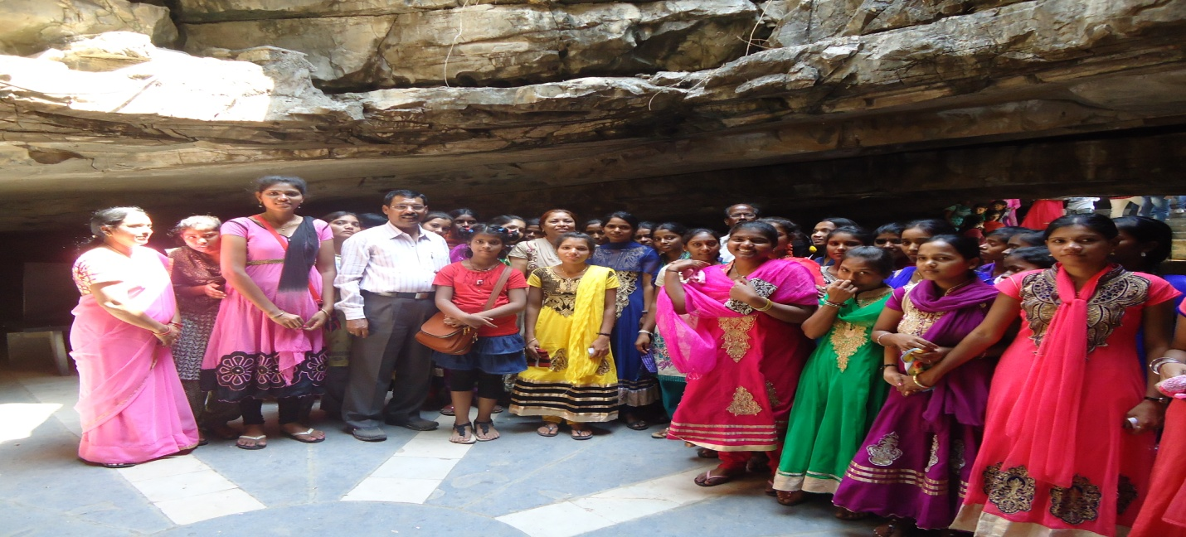

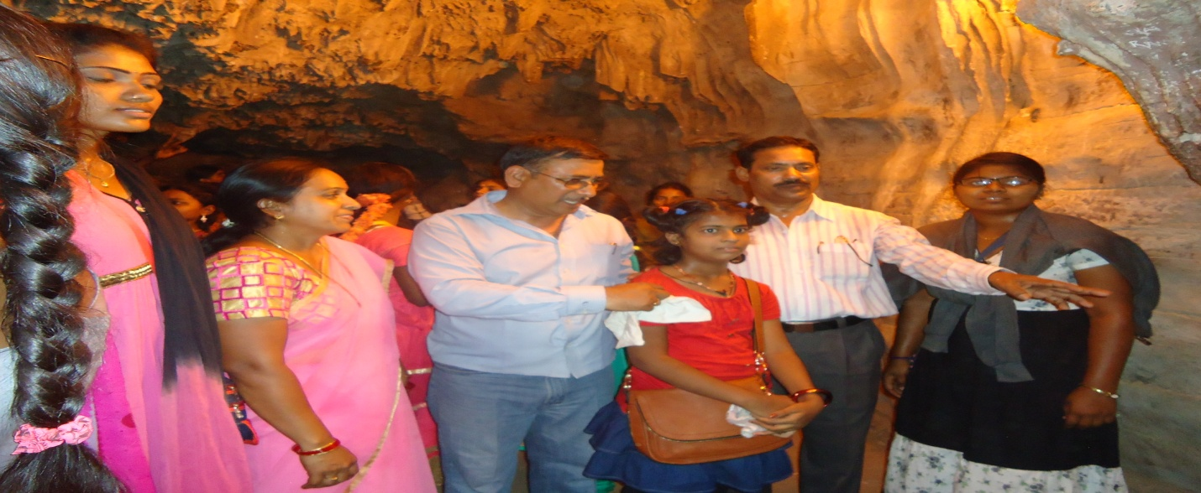

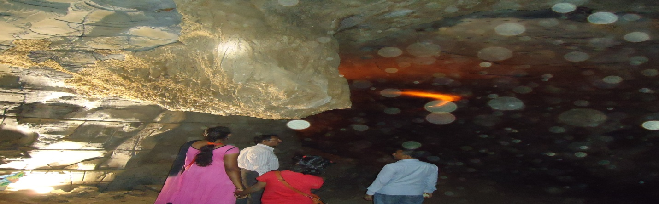

**College Trip (Tadipatri Temples)**

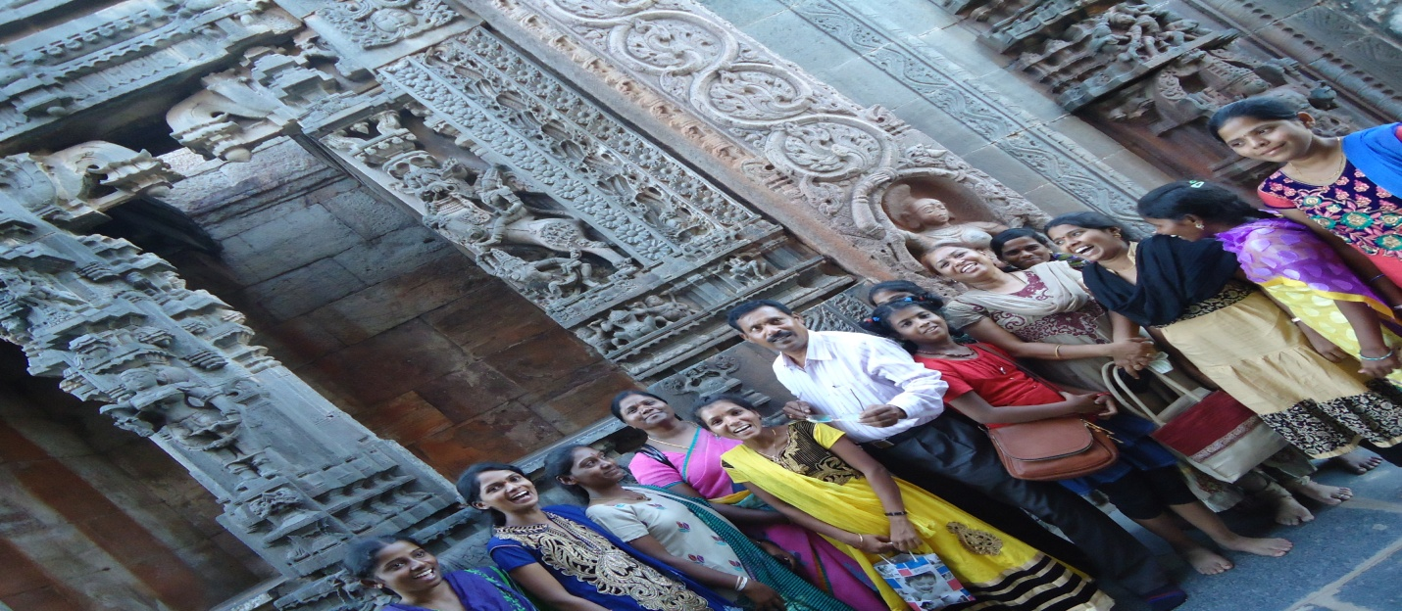

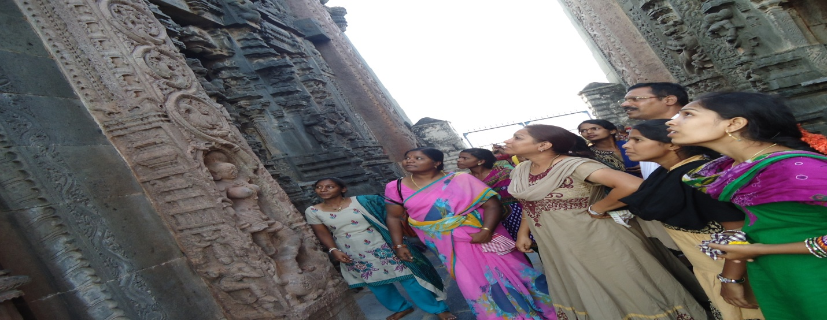

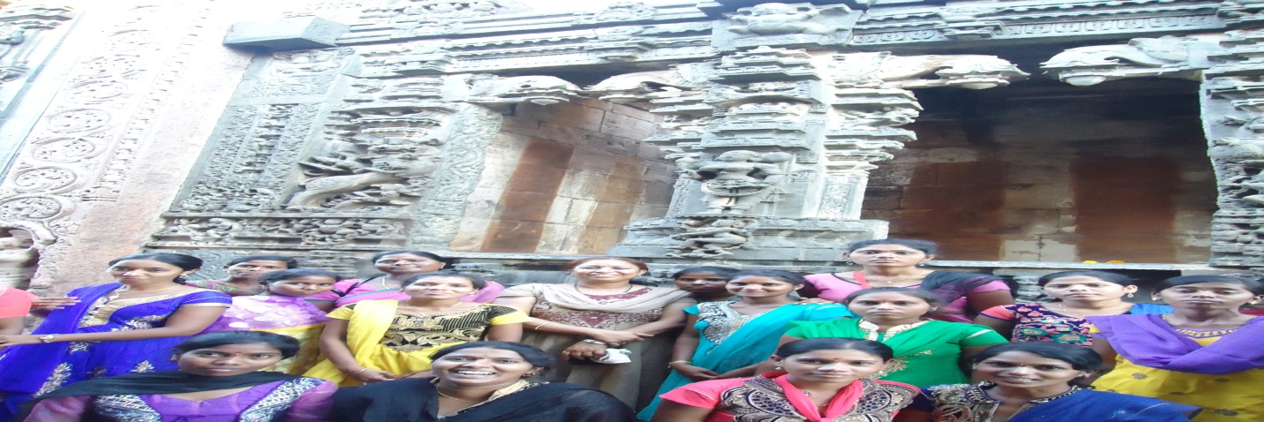

**Visit to District Jail**

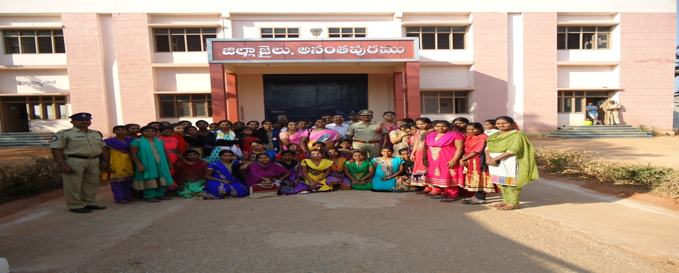

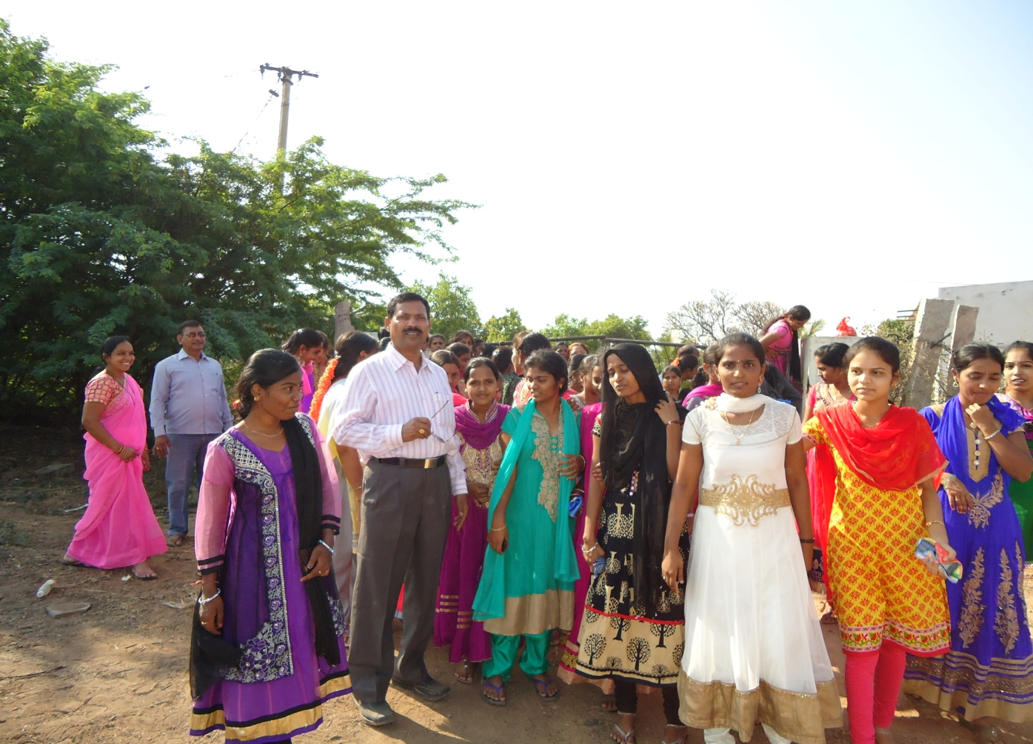

**Student Seminar I BA Sravani**

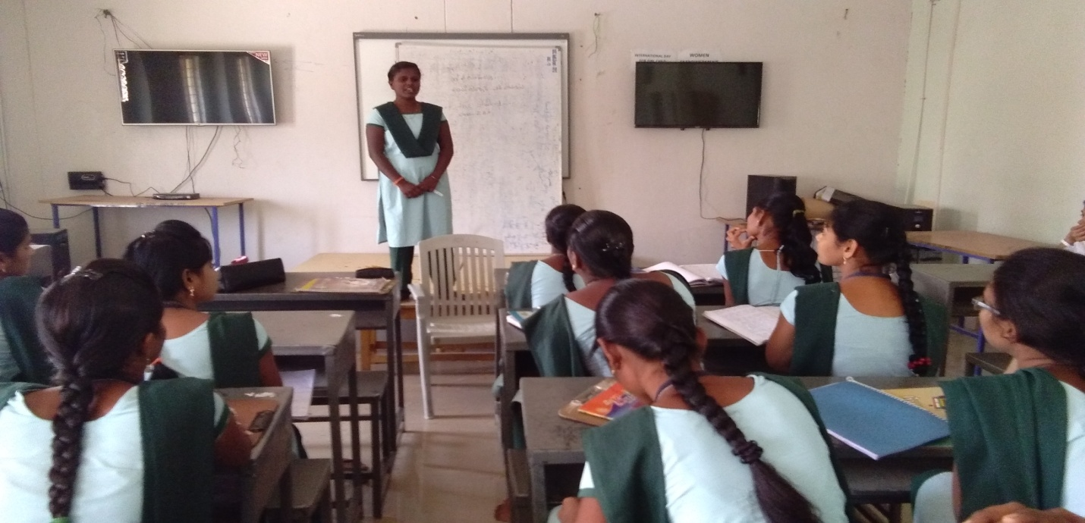

**Watch Mana TV III BA Students**

